- Coordinates and Graphics
1. A triangle ABC is formed by the points A (3,4), B (-7,2), and C (1,-2).
(a) Find the coordinates of the mid-points k of AB and p of AC (1 mk)
(b) Find the equation of the perpendicular bisector of the line kp (2 mks)
2. The size of an interior angle of a rectangular polygon is 6 ½ times that of its exterior angle.
Determine the number of sides of the polygon.

3. The sum of interior angles of two regular polygons of sides n and n + 2 are in the ratio 3:4.
Calculate the sum of the interior angles of the polygons with n sides

4 . The area of a rhombus is 60cm². Given that one of its diagonals is 15cm long. Calculate
the perimeter of the rhombus.

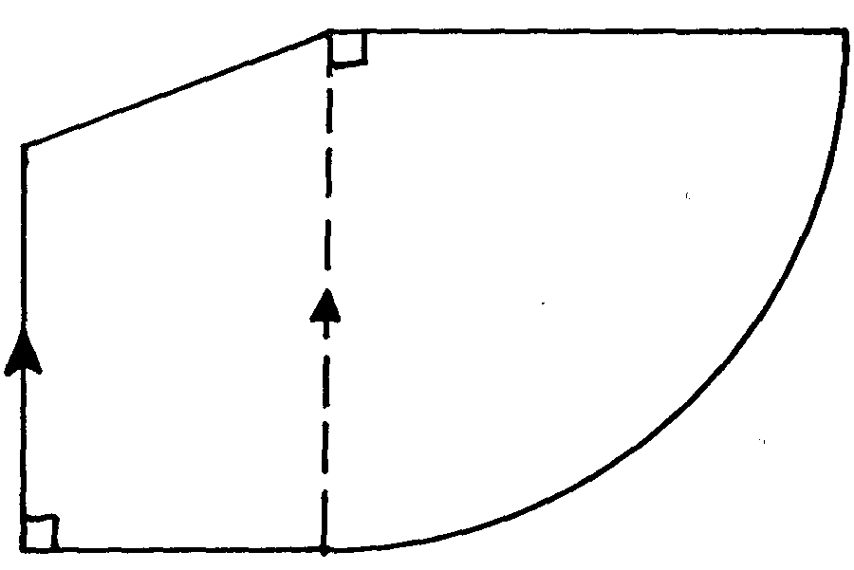
5. In the figure below AE is parallel to BD. BC = BD, AB = 7.25cm, AE = 15.25cm and
A
B
C
D
E
7.25
5.25
15.25
ED = 5.25 cm

Find the perimeter of the figure .

6. The figure below shows a trapezium ABCD in which side AB is perpendicular to both AD
and BC. Side AD=17cm, DC=10cm
17cm
9cm
10cm
B
A
D
C
xº

(i) What is the length of side AB
(ii) Find the value of cos(90º – xº) in the form a where a and b are integers
b
7. The size of an interior angle of a regular polygon is 3xº while its exterior angle is (x-20)^{o.}
Find the number of sides of the polygon

x-25
2x + 40
a

8.

In the figure above, angle a is half the sum of the other angles. Evaluate the triangle

9. The sum of the interior angles of an n-sided polygon is 1260º. Find the value of n and
hence deduce the polygon

10. Giving reason, find the angle marked n
80º
40º
n
A
B
C
D
F
E

11. Solve for y in the equation 125 ^{y+1} + 5^{3y} = 630

12. The interior angle of a regular polygon is 108º larger than the exterior angle. How many
sides has the polygon?

13. The interior angle of a regular polygon is 4 times the exterior angle. How many sides has
the polygon

14. In the figure below ABCD is a trapezium with DC parallel to AB. DC = 5cm, CB = 4cm,
D
A
B
C
8cm
4cm
5cm
10cm
BD = 8cm and AB = 10cm

Calculate:
(a) the size of angle BDC
(b) the area of triangle ABD

15. In the figure below, DE bisects angle BDG and AB is parallel to DE. Angle DCF = 60º
100º
60º
C
E
G
F
D
A
B
and angle CFG = 100º

Find the value of angle:-
(a) CDF
(b) ABD
16. The size of an interior angle of a regular polygon is 4xº, while its exterior angle is (x – 30)º.
Find the number of sides of the polygon

17. The sum of interior angles of a polygon is 1440º. Find the number of sides of the polygon
hence name the polygon

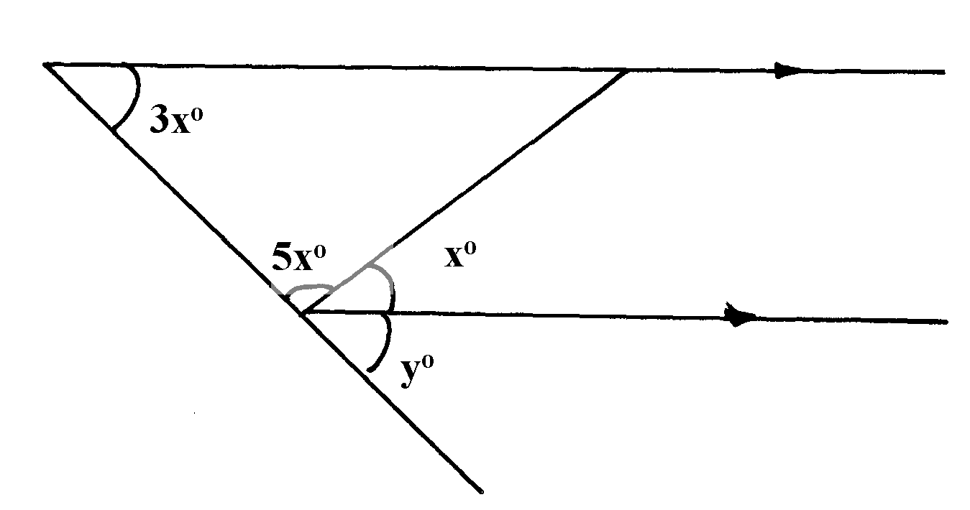
18. In the figure below PQ is parallel to RS. Calculate the value of x and y
Q
S
T
Q
P

19. The interior angle of a n-sided regular polygon exceeds its exterior angle by 132º.
Find the value of n

